1

1

1

1

1

1

0

0

0

0

0

0

0

0

0

0

0

0

0

1

1

1

1

1

1

1

1

0

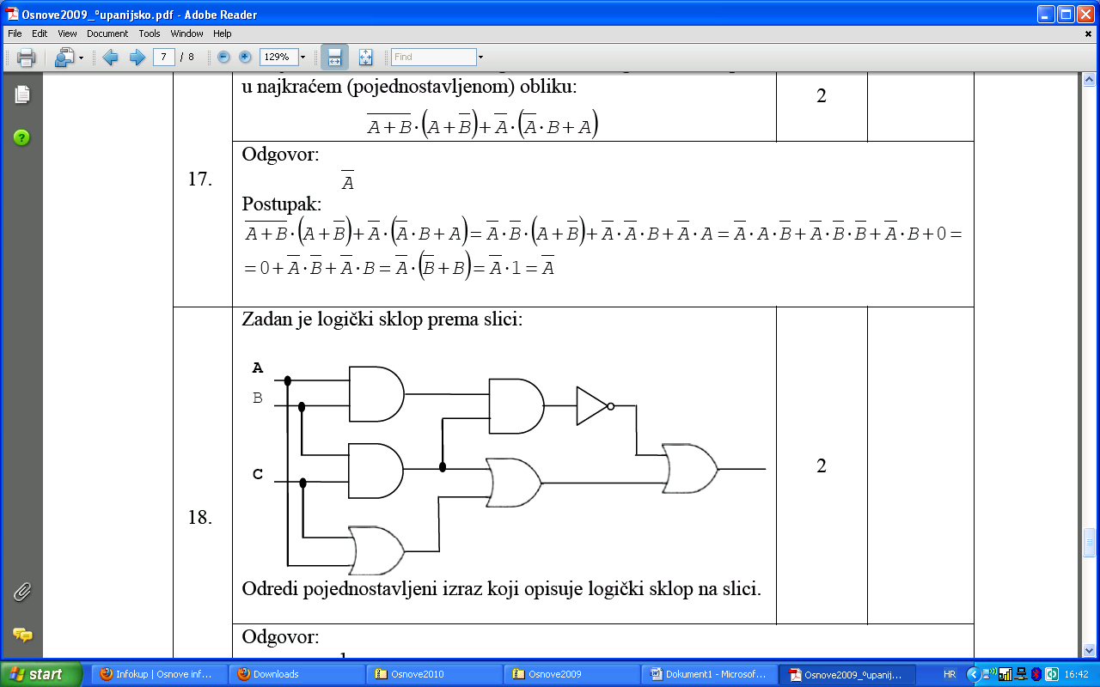

0

1

1

0

1

1